Pokhara University

Level: Bachelor | Semester – Fall | Year : 2009
Programme: B.E. |  | Full Marks : 100
Course: Digital Signal Processing |  | Time : 3hrs.

Candidates are required to give their answers in their own words as far as practicable.
The figures in the margin indicate full marks.

Attempt all the questions.

1. | - Why do we need to perform digital signal processing? Compare digital signal processing with analog signal processing? What are the limitations of digital signal processing? Discuss.  - Given the analog signal find the following:  - What is the Nyquist rate for this signal?  - If this signal is sampled using sampling rate 5000 samples/sec; what is the discrete time signal obtained after sampling?  - What is the data rate if each input sample is quantized into 1024 different voltage levels?  - What is the analog signal 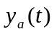 that can be reconstructed from samples if we use ideal interpolation? | 7  8
2. | - A discrete time system can be  - Static or dynamic  - Linear or non linear  - Time invariant or time varying  - Causal or noncausal  - Stable or unstable  - What is convolution? Write steps to perform convolution of two sequences (graphically).  - State and prove the necessary and sufficeint conditions for stability of LTI systems. | 5  5  5
3 | - Define z-transform and Region of Convergence. Find z-transform of following signal using properties.  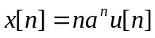, Also mention ROC of this signal  - The step response of a causal, stable LTI system is:  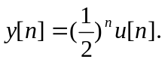  Where u [n] is the unit step function.  - Find the z-domain transfer function of this system.  - Find the impulse response h [n] of this system.  - Find the linear constant coefficient difference (LCCD) equation that describes this system.  - Plot magnitude response of this system | 7  8
4. | - Find out the circular convolution of two sequences x1[n]&x2[n] such that  x1[n]={1,2,3,4}  x2[n]={4,3,2,1}  - Given a sequence x(n)={0,1,2,3,4,5,6,7}, determine x[k] using DIT FFT algorithm. | 7  8
5. | - Determine the cascade and parallel realizations for the system described by the system.  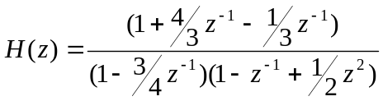  - Draw the lattice structure for the following IIR system  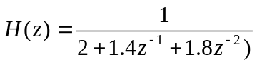 | 7  8
6. | - Explain how the windows are used to design FIR filters? Explain with examples of Rectangular and Kaiser windows.  - Explain symmetrical and asymmetrical FIR filters. | 8  7
7. | Write short notes on (Any Two):  - Gibb's Phenomenon  - Bit serial arithmetic implementation of DSP processor  - Recursive and nom-recursive system. | 5x2

